VESTIBULAR SCHWANNOMA –RADIOSURGERY OR EXPECTATION –

V-REX

**Principal investigator : Morten Lund-Johansen MD PhD**

**Treating center and clinical follow-up:**

**Department of neurosurgery**

Erling Myrseth MD PhD

Cathrine Nansdal Breivik MD PhD

Øystein Tveiten MD

Terje Sundstrøm MD

Paal Henning Pedersen MD PhD

**Department of ENT**

Frederik Goplen MD PhD

Flemming Vassbotn MD PhD

Kathrin Nilsen MD

**Statistics:**

Roy M Nilsen PhD

**Study monitors:** Monica Finnkirk, Linda Fauske

**Steering committee:**

**Neurosurgery:** Morten Lund-Johansen MD PhD

**Statistician:** Anders Engeland

**Dep of neurology:** Anette Storstein MD PhD

**Department of radiology** Renate Gruener PhD

**Dep of oncology:** Øystein Fluge

**Dep of ENT:** Greg Jablonski MD PhD

**Summary:**

The purpose of this study is to compare the outcome of patients with vestibular schwannomas in two groups of randomised to either radiosurgery or expectation.

The optimal treatment for a small vestibular schwannoma is a matter of controversy and there are no class 1 studies investigating this. Even the natural tumor growth rate remains controversial and is reported to be from near 100% of cases showing growth to 40-60% in various reports. The clinical results of various treatment strategies are documented, but comparative studies are very few. Immediate radiosurgery or wait-and scan with subsequent treatment upon growth are two strategies that have both been used in many different centers. There are only two studies comparing these treatment modalities (Regis, Breivik). These studies indicate significant effect of GKRS in reducing tumor growth, with less differences in hearing and complaint outcomes. None of the studies are blinded or randomised, allowing for bias.

The present study aims at comparing the two modalities above. To achieve this, we intend to randomise patients with newly diagnosed VS to either of Wait-and Scan or immediate radiosurgery.

The primary study endpoint is the relative tumor size measured as the ratio between tumor volume at four years compared with volume at inclusion. Secondary endpoints include symptom and sign development measured by clinical examination and by patient’s responses to standardised validated questionnaires. In addition, the health economics involved with both strategies will be evaluated and compared, as well as the patient’s working status.

Patients will be asked to participate if their VS is diagnosed within the last six months, their age is between 18 and 70, and pending there are no exclusion criteria (see below). A power analysis indicates that about 60-70 patients per group is sufficient.

The study will be announced in the Norwegian ENT-environment which diagnose most new cases of VS. In case of failure to recruit patients, we will change the design to a study based on patient’s own choice of treatment.

The study will be announced according to international guidelines. A steering committee will monitor the study and an intermediate analysis will be performed when the study group has been followed for two years. If the effect aim is already observed, the study should nonetheless continue, as it is too early to evaluate the results after such a short time course.

It will also be discussed to do a follow-up of all patients ten years after inclusion.

**Background:** Patients with a small vestibular schwannoma (VS) face the risk that progressive tumor growth may cause severe health problems, but the tumor grows slowly, and may not grow at all for many years. Most patients will experience complaints caused by the tumor interfering with the audiovestibular system, but only in a minority of cases symptoms caused by compression of brainstem or raised intracranial pressure is seen. VS is treated by one of several methods, usually Gamma Knife radiosurgery (GK) or Conservative Management (CM), the latter implying repeated MRI and treatment if the tumor grows. The aim of treatment is to stop further tumor growth, but it is uncertain if treatment leads to any other particular advantage than arresting further growth.

Patients who have useful hearing on the affected side face the risk of progressive hearing loss whether the tumor is treated or not. It is uncertain which of the two strategies (CM or GK) that may be the best choice for the patient, in particular concerning hearing.

Tinnitus, and balance disturbances are common in VS. The effect upon any of these complaints by various treatment strategies is poorly defined. Finally, the complaints caused by the tumor leads to a measurable reduction in Health-Related Quality of Life (QOL). We have demonstrated that the main factor associated with a reduced QOL is balance disturbances and dizziness (Myrseth, 2006).

There are only two studies worldwide comparing the two treatment strategies CM and GK. One French study comparing radiosurgery and observation in very small tumors concluded that growth was evident in nearly all cases in the observational group. Growth was stopped in the GK group, but hearing outcomes were no better in the treated cases than in observed (Regis, 2010). Our own study of small and middle-sized tumors found no difference in the risk of developing unilateral hearing loss in the two groups (figure 1), but we found a highly significant reduction in volume doubling time in treated cases (Figure 2, Breivik, Neurosurgery, in press). Both of the studies above provide no better than level II-III evidence.

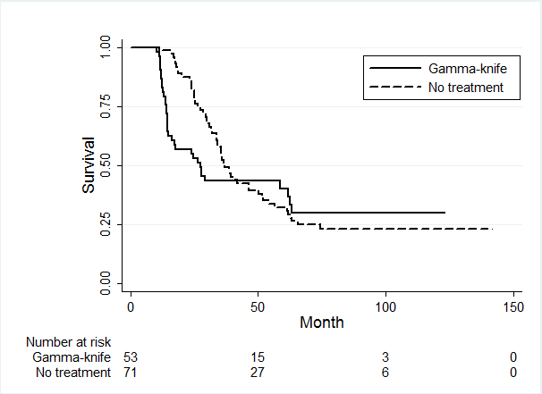

*Figure 1. Progressive hearing loss (conversion from good to poor hearing according to a defined scale) showing no difference between groups in pts treated with GK or CM. The vast majority of pts have lost hearing by five years.*

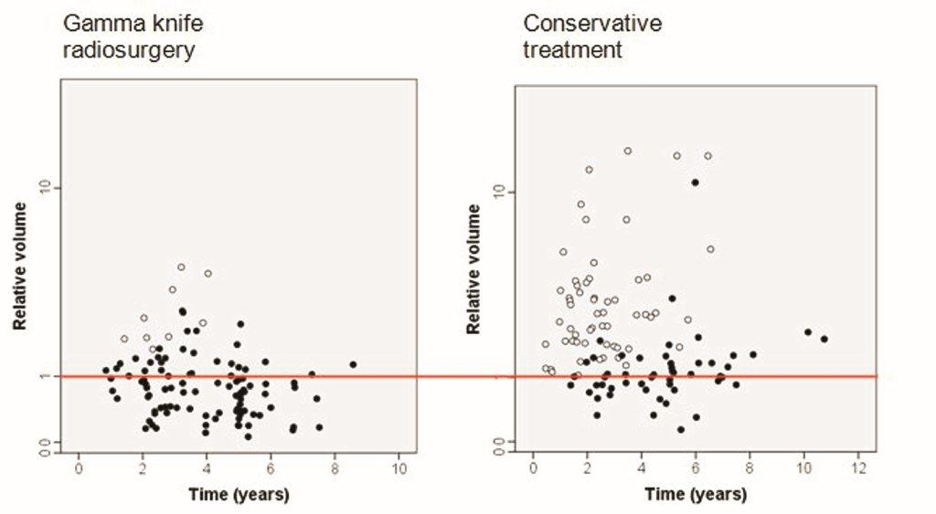

*Figure 2. Relative tumor size (final compared with baseline) versus time in patients treated with GK (left) or CM right. Open circles: patients forwarded to second treatment. Red line: indicates a ratio of 1. Tumors below the line are thus smaller, and above line larger than at baseline. There is a highly significant growth reduction caused by GKRS, as well as a highly significant reduction of patients undergoing any more treatment.*

The level of evidence for choosing a treatment strategy for VS is poor. There are two level II studies; (Pollock, 2008) and our own (Myrseth, 2010) comparing surgery and GK. Both show a higher proportion of treatment-associated morbidity with surgery. There are also five (at least) class III studies also supporting the use of GK instead of Surgery. Therefore, the collected evidence is equivocal in favouring GK above surgery as primary treatment for small and medium-sized VS. Therefore, based on the existing evidence, the treatment of choice for small and medium-sized VS, if treatment is to be given, is Gamma Knife Radiosurgery.

There is however little data to guide us in advising the patient of radiosurgery or conservative management given the tumor is small.

The timing of GKRS for small tumors has been debated. Many centers favour repeated scanning (conservative management, CM) instead of treatment upon diagnosis. Only two studies compare GKRS and Wait-and scan. (Breivik 2013, Regis 2010) . Both studies indicate a significant growth reduction achieved by GKRS, and less difference between groups regarding complaints.

There is a growing debate on how VS can be best treated as it has become clear that the tumour may remain unchanged in size for years following diagnosis. A careful follow-up by MRI, so-called ‘‘wait and scan’’, has therefore emerged as a safe way of management in VS patients with small and medium-sized tumours. In a recent meta-analysis of VS growth, Yoshimoto found 22 retrospective and 4 prospective studies including 1340 patients . The proportion of tumours showing growth varied considerably, from 15 to 85% in the different reports (average 46%), and the mean growth rate was 1.2mm/year during a mean observation period of 38 months (range 6–64). Any progression of symptoms, such as hearing loss, may be considered a failure of conservative treatment. Studies indicate that between one third [141] and one half [123] of conservatively managed VS patients loose useful hearing over a period of three years.

Our own prospective study utilizing volumetric measurements indicate that growth may be detected in 60-80% of cases over a 4.5 year period, but it is of less significance in many cases, leading to treatment only in 41% (Figure 3)



*Figure 3. Relative tumor volume change in 178 VS tumors observed for 5.1-105.6 months (mean 43.3). From: Varughese et al, 2012). Crosses: patients allocated to treatment. Open circles: patients remaining in the conservative management group.*

GKR has been used for more than three decades, and worldwide an increasing number of VS patients receive treatment by GKR, which is now the most-used treatment. The aim of GKR is tumour control, defined as either reduced or unchanged tumour volume. The majority of centres report tumour control rates between 89 and 100%, but few centers report observation periods longer than five years. The tumour growth rates before GKR (or surgery) are usually unknown in reported series. Consequently, a proportion of treated tumours might have remained unchanged without any treatment at all.

We therefore believe that prospective comparative studies need to be carried out before patients can be advised on a statistical basis about the relative merits of conservative management or GKR in relation to growth and hearing preservation. Failure, defined as conversion from ‘‘wait and scan’’ to active treatment, is reported in 15–50% of patients in various studies. The authors do not report in detail why failure occurred, but tumour growth, increasing symptoms and patients’ own preference were probably the main reasons.

**Aim of study:**

The null hypothesis is that Gamma Knife Radiosurgery given to a small Vestibular Schwannoma produces no difference in growth rate of the tumor (primary endpoint) or clinical parameters, in particular hearing, (secondary endpoints) compared with untreated patients within a time frame of four years.

* First, one may document the “growth control rate” expressed as the change in tumor volume over a two- and five year period, following GKRS compared with that of an untreated tumor.
* Second, one may clarify whether GKRS treatment causes less or more decline in hearing acuity than what is found after a conservative approach.
* Third, by applying a panel of standardised and validated questionnaires directed against tumor-related symptoms affecting health-related quality of life, one may detect differences between groups not found by other methods.
* Fourth, by applying a standardised panel of Vestibular function tests, one may assess the effect of GKRS on the balance organ compared with that caused by the natural course of the tumor.

**Study design and purpose:**

**Design:** Randomised study blinded to observer on primary endpoint (tumor volume). Intention-to-treat, ie patients who cross over from conservative to GKRS group during the study period are assigned to their original group. Patients who refrain from radiosurgery despite randomisation are assigned to radiosurgery group.

**Purpose:** compare the treatment of small and medium-sized VS treated with a standardised dose of 12 Gy to the tumor periphery with expectative treatment.

**Inclusion criteria:** Newly diagnosed VS by MRI of less than 6 months. CPA diameter <20mm. Willing to participate. Age 18 -70 years.

**Exclusion criteria:**

Unwilling/not fit for participation for other reasons (alcohol abuse, personality disorder/language problems).

Severe co-morbidity:

Dementia

Active malignant disease

Type II neurofibromatosis in patient or first grade relative.

Other severe co-morbidity

Age less than 18 or more than 70 years.

**Primary endpoint:**

Growth measured as volume ratio V4years/Vbaseline and 1/volume doubling time, evaluated by T1 contrast MRI volumetry at two and four years.

**Secondary endpoints:**

Hearing acuity according to Gardner Robertson scale at four years (safety endpoint).

Conversion to other treatment during study period

Adverse effects

Subjective complaints assessed by questionnaires:

Penn Vestibular Schwannoma QOL Scale

Hospital Anxiety Depression Scale

**Investigations:**

Prior to inclusion: MRI less than 6 months showing VS.

After inclusion and at 1,2 3,4 years, all at study site:

MRI of inner ear (acoustic neuroma protocol)

Balance platform

Nystagmometry

Audiometry

**Treatment:**

Patients receiving radiosurgery undergo treatment within 2 months following randomization. Radiosurgery is given according to a standard dose plan of 12 Gy to the tumor periphery. The maximal dose, number of shots and the brainstem and cochlea doses are reported. Patients undergoing observational treatment are assigned to such. Any additional treatment of tumor or tumor-related conditions or complaints (such as VP shunt for hydrocephalus) is reported.

**Statistical method:**

The difference between groups is reported as mean (95% CI or OR for categories). Baseline data are compared. The difference between groups from baseline until four years is compared by paired (two-sided) t-test. Multiple regression is used to perform predictor analysis. Randomization (bloc) is done by matching groups for age and extra/intracanalicular tumor.

The observer interpreting the MRI scans is blinded to treatment, to reduce bias.

**Study population size:** We performed two power analyses based on data from our own database.

*Based on hearing outcomes:*

In the first power analysis, we examined the number of patients needed to demonstrate if the two groups would be similar or different in hearing outcome.

*Test for difference:*

Power (1 – Type 2 error): 0.8 or 0.9 (the probability of reject H0 when H0 is false)

Type 1 error: 0.05 (the probability of reject H0 when H0 is true)

One usually wants a Power of 80% or more and a low Type 1 error.

Scenario 1 – Difference in proportions (Gardner-Robertson)

We want to determine the sample size for a 5 year vestibular schwannoma trial with gamma knife therapy and a control group with no treatment. The primary outcome is hearing loss, defined as useful to no useful hearing (binary outcome). We desire a 0.05-significance level test with 90% statistical power. The proportion of no useful hearing at 5 year follow-up in a similar population is 54%. We plan to have equal allocation to the two treatment groups.

Scenario 2 – Difference in means (% of perfect hearing)

We want to determine the sample size for a 5 year vestibular schwannoma trial with gamma knife therapy and a control group with no treatment. The primary outcome is hearing loss, defined as the percentage of perfect hearing (100% excellent hearing and 0% deaf). We desire a 0.05-significance level test with 90% statistical power. The standard deviation observed from a similar population is 35. We plan to have equal allocation to the two treatment groups.

*Test for equivalence:*

Power (1 – Type 2 error): 0.90 or 0.95 (the probability of reject H0 when H0 is false)

Type 1 error: 0.10 (the probability of reject H0 when H0 is true)

One usually wants a higher Power (90% or more) and a higher Type 1 error.

Scenario 3 – Equivalence in means (% of perfect hearing)

We want to determine the sample size for 5 year vestibular schwannoma **equivalence** trial with gamma knife therapy and a control group with no treatment. The primary outcome is hearing loss, defined as the percentage of perfect hearing (100% excellent hearing and 0% deaf). We desire a 0.10-significance level test with 95% statistical power and decide that the zone of equivalence is (-15%, 15%) and that the true difference in means does not exceed 0%. The standard deviation observed from a similar population is 35. We plan to have equal allocation to the two treatment groups (Figure 4, below).

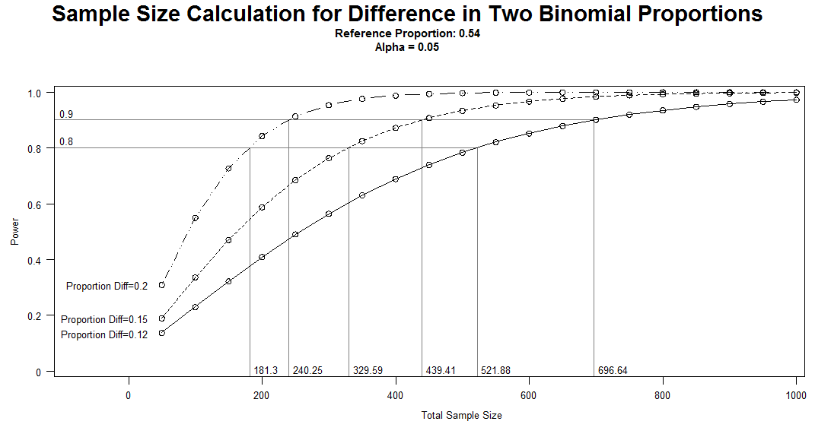

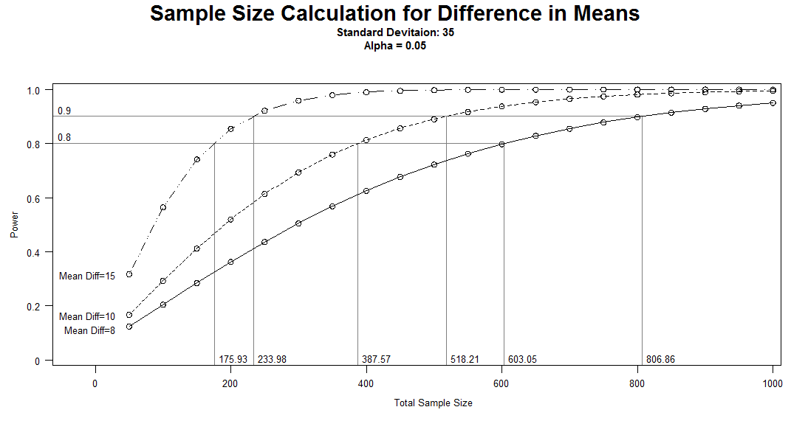

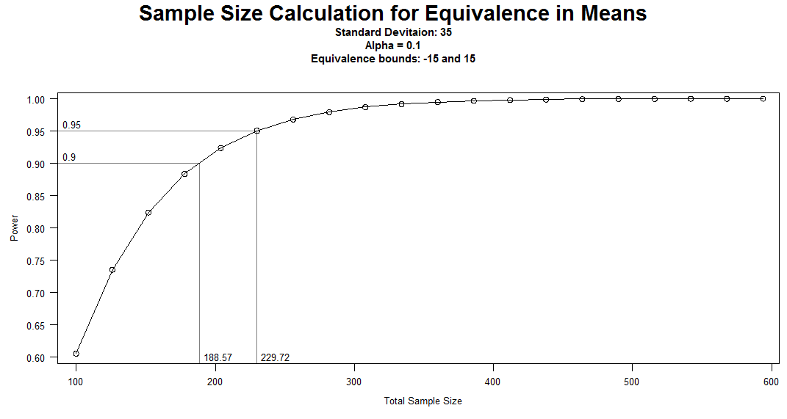

*Figure 4. Hearing acuity as suggested endpoint.*

*Tumor size as endpoint*

The second endpoint concerned changes in tumor size. The analysis indicates that a sample of about 130 patients divided into two groups would be sufficient to demonstrate a difference in tumor size within two years at a power of 80 (Figure 5, below).

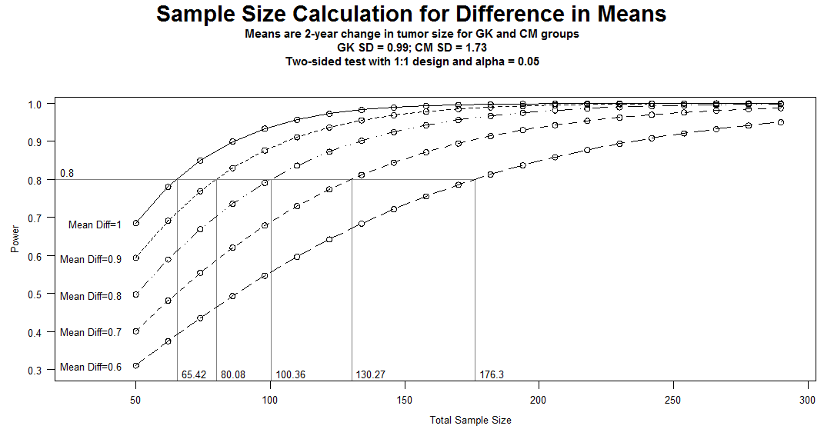

*Figure 5. Tumor size as suggested endpoint.*

Based on the power analysis, the study seemed to be feasible only to demonstrate the effect of GKRS on tumor volume, as the number of patients needed to demonstrate difference or similarity in hearing outcomes was unrealisticly high.

**Effect registration:**

Main variable:

Tumor volume, measured on a T1 contrast MRI scan with 2mm slice interval/thickness. For study, the measurement is to be done by a blinded observer.

*Recruiting patients.*

The National Center for Vestibular Schwannoma get referred about 100 patients per year. Our experience is that these patients are easy to recruit to studies, and we believe recruiting 40-50 per year is feasible. Thus, the study may be completed within a period of 4-5 years for the 2-year outcome and 5-7 years for the 4-year outcome.

*Personnel.*

We have the necessary means to perform the clinical follow-up within the two departments. Database tools are to be developed. A steering group consisting of specialists within the different subject has been established.

*Economy.*

Costs associated with study are financed by research donations from Helse-Vest and The National Center for Vestibular Schwannomas.

Patients are recruited from outpatient consultations, and most of the routine patient handling is financed over the departments’ budgets. Data are collected according to clinical consultations that take place routinely at follow-up, with the additional assessment of a blinded observer.

Costs will imply:

Database construction

Questionnaire/CRF generation.

Generation of data files from radiology

Study nurse (50% position for 5-6 years).

Research fellow(s) 1-2. We will apply for such personnel in appropriate time, when the study has been running sufficiently long.

**Data management and patient safety.**

Data is kept at the “research server” at HUS, following approval by REK. Key list is kept at separate file on research server only accessible to study monitor.

One issue that has been particularly dealt with is the risk of radiation-induced tumors. It is known that any amount of irradiation may increase the risk of neoplasia. The current knowledge about the risk of getting a CNS tumor after receiving radiosurgery is one single study by Rowe and coworkers. They compared the development of secondary neoplasia in a large material of English patients receiving radiosurgery for benign intracranial lesions using data from the National Cancer Registry. They found that the incidence of neoplasia in irradiated patients was lower than expected when compared with the overall population, but the difference was not statistically significant. Therefore, if any, the increased risk of secondary neoplasia following radiosurgery seems to be very low. Except for this one issue, we are not aware of any safety hazard related to this study.

**Study schedule**

|  |  |  |  |  |  |  |
| --- | --- | --- | --- | --- | --- | --- |
|  | Control  (CRF) | questionnaire | economy | MR | Audiometry+SD | OTO |
| Inclusion | √ | √ | √ | √ | √ | √ |
| 1 years | √ | √ | √ | √ | √ | √ |
| 2 years | √ | √ | √ | √ | √ | √ |
| 3 years | √ | √ | √ | √ | √ | √ |
| 4 years | √ | √ | √ | √ | √ | √ |

**Details on study maintenance.**

Patients are recruited from the pool referred to the VS meeting. They are presented with the study at the ENT outpatient clinic on examination. If they agree, consent is signed and baseline data are recorded including questionnaires and audiovestibular examination. Additional scan is done in patients who are randomised to CM. Patients are randomised before they leave the hospital. Patients who get randomised to GK return to the hospital within 2 months for treatment.

Schedule is repeated after 1, 2, 3 and 4 years. A ten-year follow-up may be considered at study end.

*Study follow-up:* For audiovestibular tests and clinical CRF, the patient is examined by a doctor/technician in the ENT or neurosurgery.

*Radiology:* Image based tumor volumes

As the primary endpoint is relative tumor size, an accurate measure of tumor volume and changes thereof, is mandatory. This will be obtained using a state-of-the-art magnetic resonance imaging (MRI) system suited for acquiring high resolution (1mm3), three dimensional (3D) anatomical images. A 1.5T imaging system which meets the required field homogeneity will be used for imaging. The image contrast will be T1 weighted with gadolinium based contrast agent, yet a T2 weighted image volume will also be included (preferably also acquired in 3D). An identical imaging protocol will be acquired at each time point (prior to randomization, on site follow up, 4-year annual follow up), and image slices will be positioned according to anatomical landmarks in each patients to minimize variability across time. All 3D acquisitions will be performed with sagittal slicing to minimize artifacts, but will also be reformatted into coronal and axial views (1mm slice thickness, no gap between slices) on the scanner system.

The subsequent imaging processing, i.e. the estimation of tumor volume and longitudinal changes thereof, will be performed using available software at time of analysis. The radiology department already has some tools to perform this task semi-automatically using commercially and open source software solutions. Furthermore, it is foreseen that this may even be more simplified now that better image processing tools will become available as the department is currently investing in new image processing solutions suitable for the current task. A (semi-)automated estimation of tumor volume is therefore considered highly feasible. All analysis will be performed centrally, i.e. at the Haukeland University Hospital supervised by senior radiologist Jonas Lind.

To assure that examinations are blinded to the observer, the patients need to be scanned both with and without a stereotactic frame. The frame can then be mounted at the preparation room for the MRI examination to minimize inconvenience for the patient and reduce access time to the scanner. *[In a pilot study (data already acquired), in-house image manipulation software will also be attempted to either digitally remove the signal from the frame from the acquired images or digitally add an artificial signal representing the frame.]* Examiner who will estimate volumes on scans is blinded to patient ID and to treatment.

LITERATURE

1: Varughese JK, Wentzel-Larsen T, Pedersen PH, Mahesparan R, Lund-Johansen M.

Gamma knife treatment of growing vestibular schwannoma in Norway: a prospective

study. Int J Radiat Oncol Biol Phys. 2012 Oct 1;84(2):e161-6. doi:

10.1016/j.ijrobp.2012.03.047. Epub 2012 Jun 8. PubMed PMID: 22682805.

2: Varughese JK, Breivik CN, Wentzel-Larsen T, Lund-Johansen M. Growth of

untreated vestibular schwannoma: a prospective study. J Neurosurg. 2012

Apr;116(4):706-12. doi: 10.3171/2011.12.JNS111662. Epub 2012 Jan 20. PubMed PMID:

22264178.

3: Breivik CN, Varughese JK, Wentzel-Larsen T, Vassbotn F, Lund-Johansen M.

Conservative management of vestibular schwannoma--a prospective cohort study:

treatment, symptoms, and quality of life. Neurosurgery. 2012 May;70(5):1072-80;

discussion 1080. doi: 10.1227/NEU.0b013e31823f5afa. PubMed PMID: 22067416.

4: Myrseth E, Møller P, Pedersen PH, Lund-Johansen M. Vestibular schwannoma:

surgery or gamma knife radiosurgery? A prospective, nonrandomized study.

Neurosurgery. 2009 Apr;64(4):654-61; discussion 661-3. doi:

10.1227/01.NEU.0000340684.60443.55. PubMed PMID: 19197222.

5: Myrseth E, Pedersen PH, Møller P, Lund-Johansen M. Treatment of vestibular

schwannomas. Why, when and how? Acta Neurochir (Wien). 2007;149(7):647-60;

discussion 660. Epub 2007 Jun 11. Review. PubMed PMID: 17558460.

6: Kondziolka D, Mousavi SH, Kano H, Flickinger JC, Lunsford LD. The newly

diagnosed vestibular schwannoma: radiosurgery, resection, or observation?

Neurosurg Focus. 2012 Sep;33(3):E8. doi: 10.3171/2012.6.FOCUS12192. Review.

PubMed PMID: 22937859.

7: Niranjan A, Mathieu D, Kondziolka D, Flickinger JC, Lunsford LD. Radiosurgery

for intracanalicular vestibular schwannomas. Prog Neurol Surg. 2008;21:192-9.

doi: 10.1159/000156973. Review. PubMed PMID: 18810219.

8: Carlson ML, Jacob JT, Pollock BE, Neff BA, Tombers NM, Driscoll CL, Link MJ.

Long-term hearing outcomes following stereotactic radiosurgery for vestibular

schwannoma: patterns of hearing loss and variables influencing audiometric

decline. J Neurosurg. 2013 Mar;118(3):579-87. doi: 10.3171/2012.9.JNS12919. Epub

2012 Oct 26. PubMed PMID: 23101446.

9: Pollock BE, Driscoll CL, Foote RL, Link MJ, Gorman DA, Bauch CD, Mandrekar JN,

Krecke KN, Johnson CH. Patient outcomes after vestibular schwannoma management: a

prospective comparison of microsurgical resection and stereotactic radiosurgery.

Neurosurgery. 2006 Jul;59(1):77-85; discussion 77-85. PubMed PMID: 16823303.

10: Stangerup SE, Tos M, Thomsen J, Caye-Thomasen P. Hearing outcomes of

vestibular schwannoma patients managed with 'wait and scan': predictive value of

hearing level at diagnosis. J Laryngol Otol. 2010 May;124(5):490-4. doi:

10.1017/S0022215109992611. Epub 2010 Jan 19. PubMed PMID: 20082740.

11: Stangerup SE, Caye-Thomasen P, Tos M, Thomsen J. The natural history of

vestibular schwannoma. Otol Neurotol. 2006 Jun;27(4):547-52. PubMed PMID:

16791048.

12: Rowe J, Grainger A, Walton L, Silcocks P, Radatz M, Kemeny A. Risk of

malignancy after gamma knife stereotactic radiosurgery. Neurosurgery. 2007

Jan;60(1):60-5; discussion 65-6. PubMed PMID: 17228253.